**Terraform conditionals**

Terraform has a taint command that informs terraform that a particular object has become degraded or damaged and during the next execution of terraform replace it.

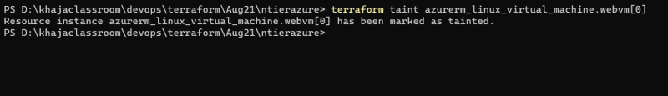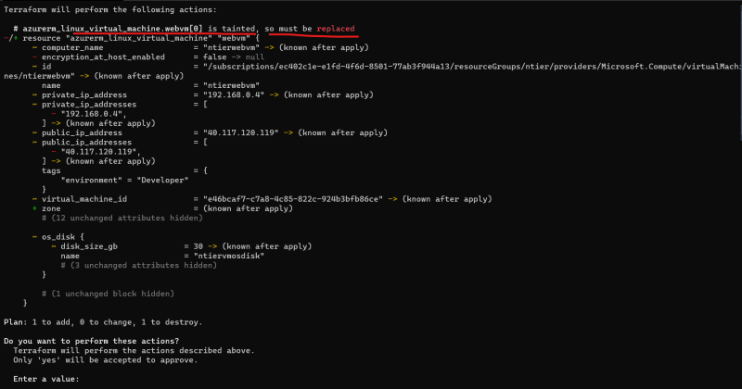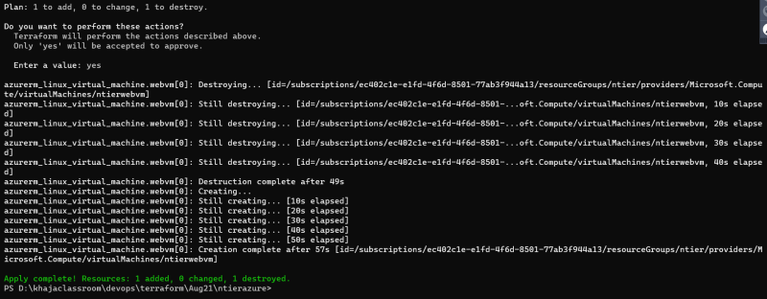

Terraform taint can be undone with untaint command 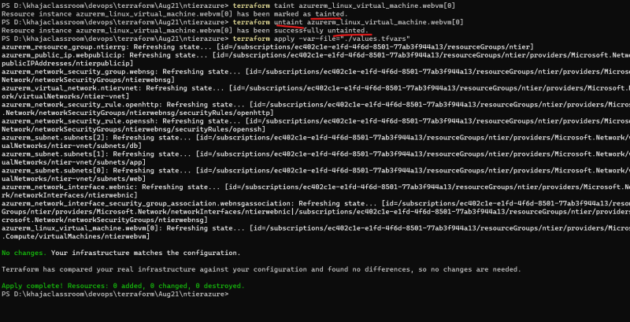

Every provider in terraform gives us data sources which we can use to pull information. The basic syntax of defining datasource is

data "type" "name" {

arg1 = value1

...

argn = valuen

}

Datasource: A data source is accessed via a special kind of resource known as a data resource, declared using a data block:

data "aws_ami" "example" {

most_recent = true

owners = ["self"]

tags = {

Name = "app-server"

Tested = "true"

}

}